Northern Digital Inc. Aurora   
Electromagnetic Tracking Equipment:

Usage Notes by Andrew Razjigaev 2023

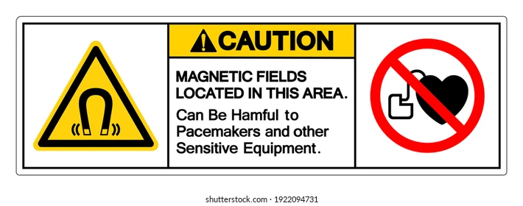

**EQUIPMENT PRODUCES MAGNETIC FIELDS**

**CAN BE HARMFUL FOR PACEMAKERS AND OTHER SENSITIVE EQUIPMENT**

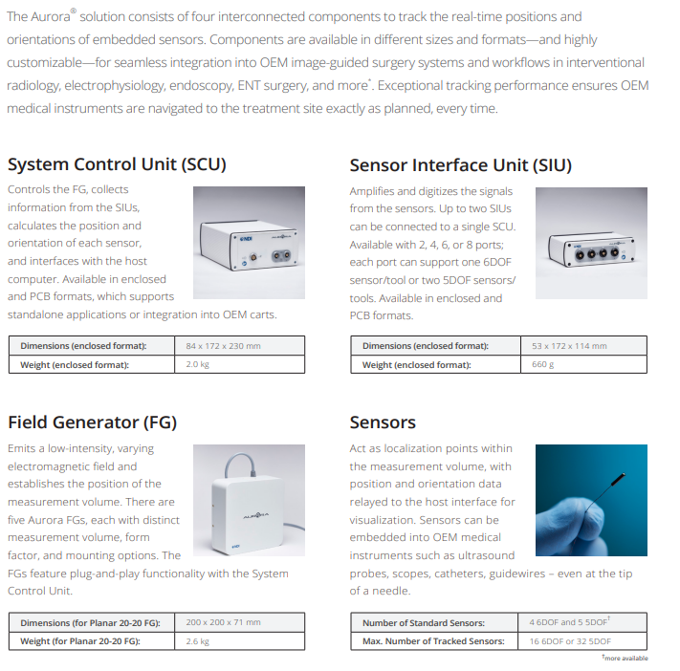**Introduction to NDI Aurora**

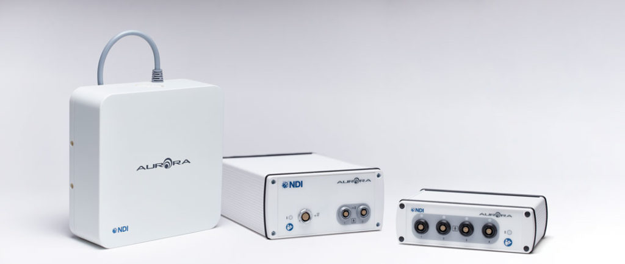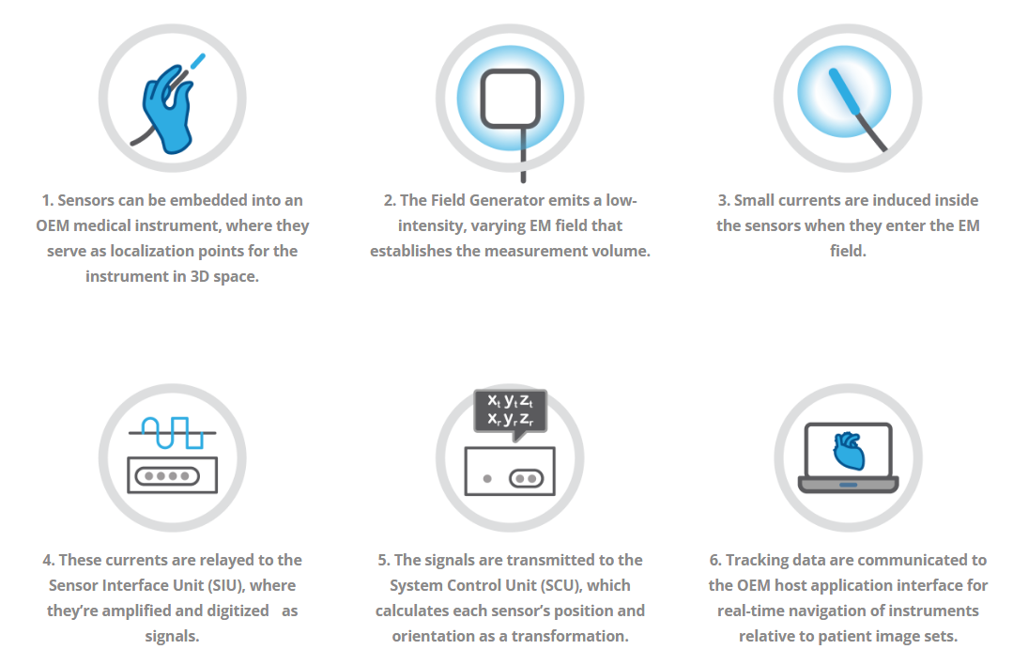NDI Aurora System:  
More details on NDI Aurora and latest products can be viewed online:

<https://www.ndigital.com/electromagnetic-tracking-technology/>

# Setup in the Lab:

Note, ensure the cable to the NDI aurora electromagnetic field generator is not wound up:

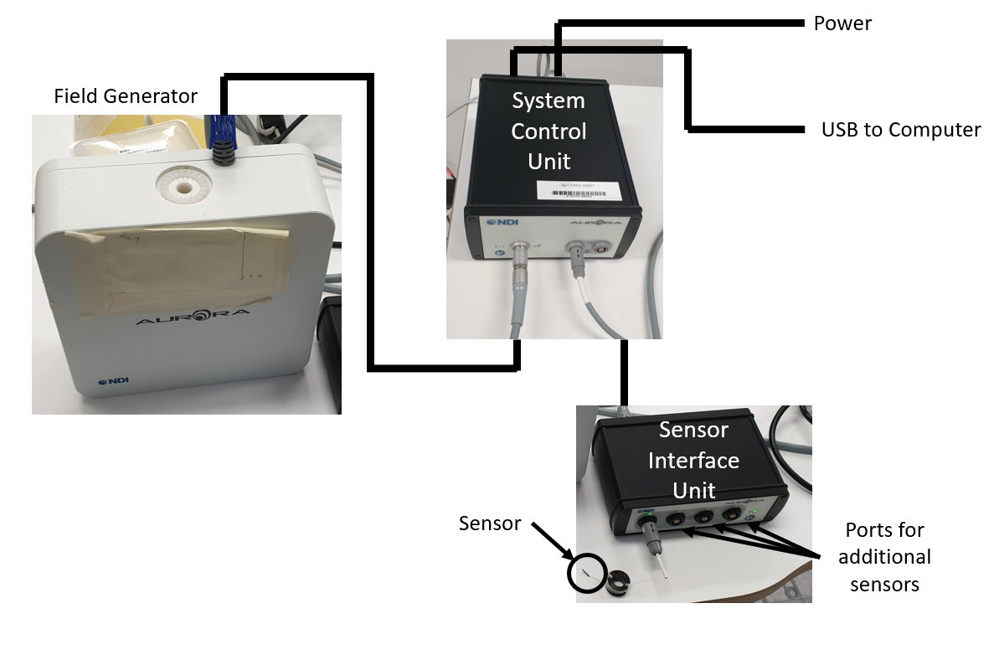

Installation for the first time: <file:///C:/Program%20Files%20(x86)/Northern%20Digital%20Inc/ToolBox/readme.htm#_USB_Drivers_Installation>

1. From the Force Dimension, USB, put the “**Northern Digital Inc**” folder into   
   **Program Files (x86)**
2. In addition, copy the folder “**CombinedAPISample**” to any location like the desktop.
3. Connect the USB port for NDI aurora
4. In the start menu, find “**control panel**” -> “**Device Manager**”
5. In device manager, find under “other” the “**NDI Aurora SCU Port**”
6. With Admin privileges, change settings and update the driver. Manually browse computer for drivers in : **Program Files (x86)\Northern Digital Inc\ToolBox\USB Driver**
7. Repeat 5-6 until a port allocated e.g. COM3
8. In the “**Northern Digital Inc**” folder run **Track.exe** and connect to COM3 (or whatever port was connected)

# Checking The Tracking

Run **Track.exe** and the GUI should automatically show the workspace and the sensor’s location whether it is trackable or outside the workspace and the electromagnetic field generator:

Note all activity with the tracker are saved in a logfile called capi.txt

# Usage for gathering data using CombinedAPISample:

1. In project folder **CombinedAPISample**, go to **Source -> Debug**
2. Run the executable: **NDI CombinedAPI Sample.exe** (Alternatively if editing the source code in Visual studio, open the **CombinedAPISample.sln** and run the program there)
3. Graphical user interface, table

   Description automatically generated with medium confidenceIn the executable, **Initialize system**, **Activate Handles** and **Start Tracking** to record data
4. 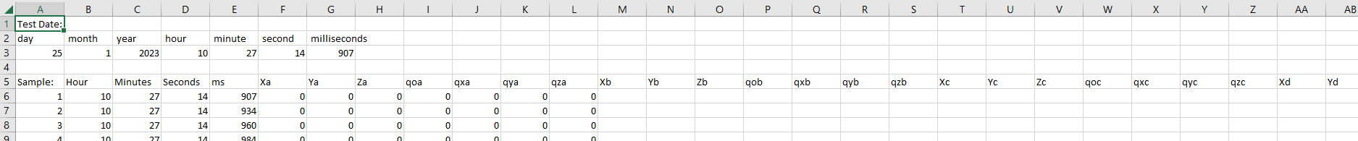In the same folder (**Source -> Debug**), a file called **NDIdata.csv** would be recording data in the form of:
5. The data records the time, position (X,Y,Z) and quaternion (qo,qx,qy,qz) for each of the 4 sensors (a,b,c,d). Note all activity with the tracker are also saved in a logfile called capi.txt
6. You can process the data in MATLAB. My repository has the code: <https://github.com/Andrew-Raz-ACRV/ndi_tracker_project> Use the command NDI_csr_to_vectors and the data in the .csv file becomes a structure of data that can be used.

# Modifying the source code of CombinedAPISample:

1. The source code can be modified in visual studio using the desktop development tools in C++. It may not compile successfully at first due to the settings in visual studio. To make it compile modify the visual studio installer setup to have MSVC tools:

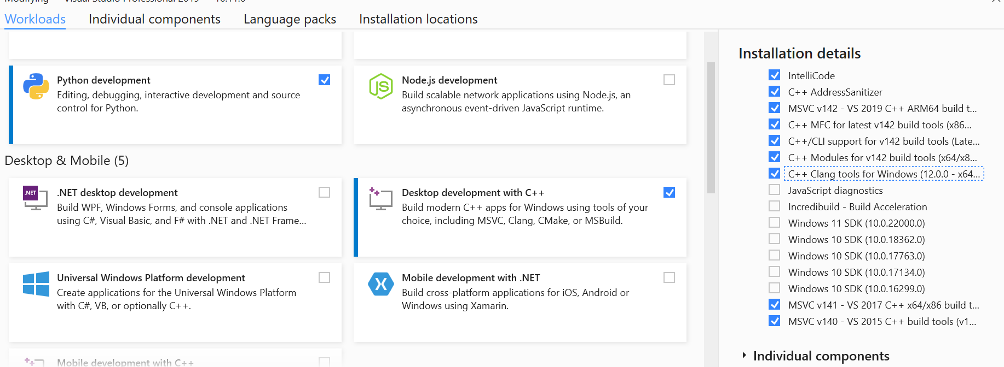

1. In project folder **CombinedAPISample**, go to **Source** and find the following file: **CombinedAPISampleDlg.cpp** which handles the communication of data. By searching ‘Andrew’ one can find my modifications for creating the .csv file capability. This modified piece of code can be found in GitHub: <https://github.com/Andrew-Raz-ACRV/ndi_tracker_project>